

Car Rental System

**Submitted By:**

**Amad Irfan**

**2021-CS-25**

**Submitted To:**

Sir. Laeeq Khan

**For Fulfillment of**

**CS 161 Programming Fundamentals**

**Department of Computer Science University of Engineering and Technology, Lahore**

**Users Of the Application: -**

**1: - Admin: -**

* **He Must have the option to add more admins as well as car owners.**

# 2: - car owner: -

* **He must have the option to add his/her cars and see the payment record.**
* **He must have the option to track his/her car.**

# 3: - User: -

* **He has to Book cars.**
* **As well as see the previous history.**

Functional Requirements: -

Admin requirements: -

* **Add admin.**

# Add cars.

* **Delete cars.**
* **Show all the cars.**
* **Shows users.**
* **Show owners.**
* **Rest available cars data.**
* **Generate Reports.**

**Car owner’s requirements: -**

* **Add car.**
* **Show all his/her cars**
* **Show Income details.**

**Wireframe of car rental system**

**Main Menu: -**

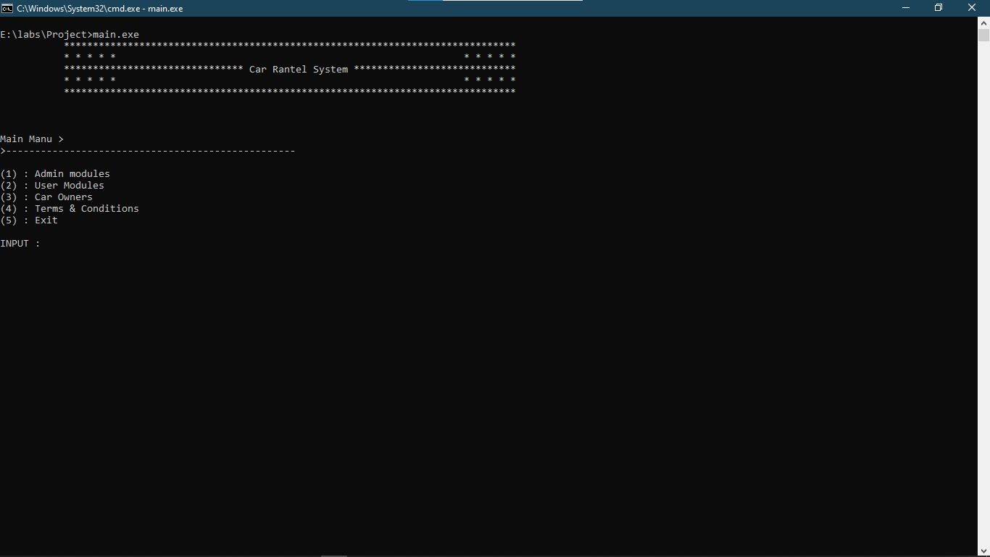

## Main Menu: -

* + **Main Menu allow the user to use the car rental application.**

As an Admin, owner as well as User.

* + **It also has an option to exit the Program at the start.**

## Admin Login Page: -

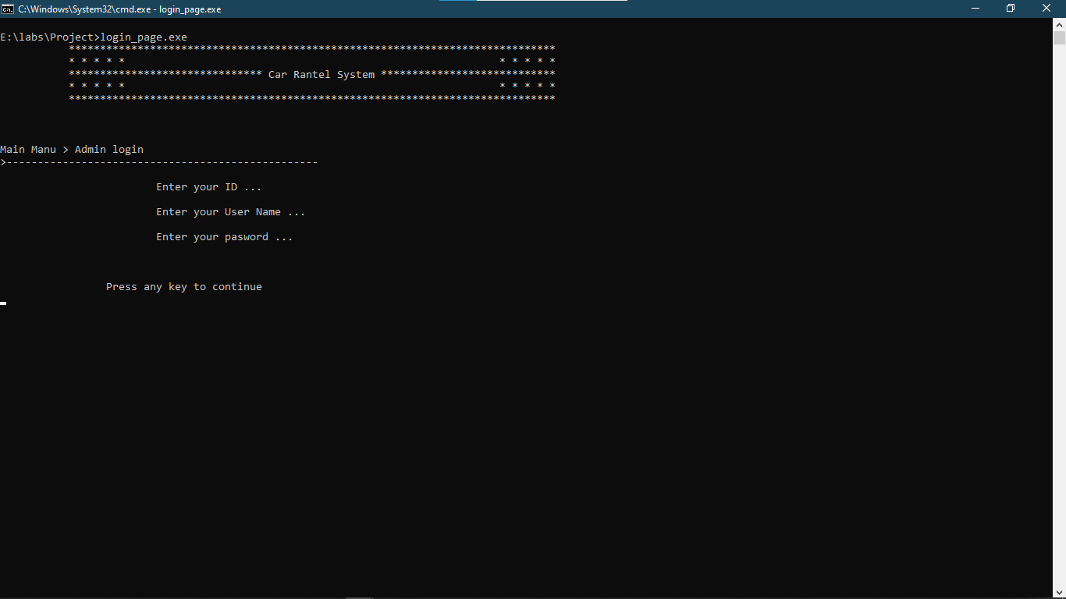

* **This page asks the admin to verify that he is really the Admin or some intruder by asking his/her user name, ID and password.**

Admin Module: -

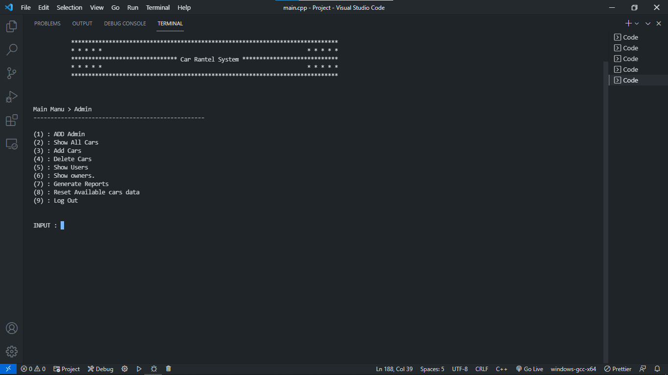

* + **This Page gives the admin the authority To show all cars, Add and delete cars, log off and search about users and owners.**
  + **It also has an option to add admin and owners.**

Car Owner’s Login Page: -

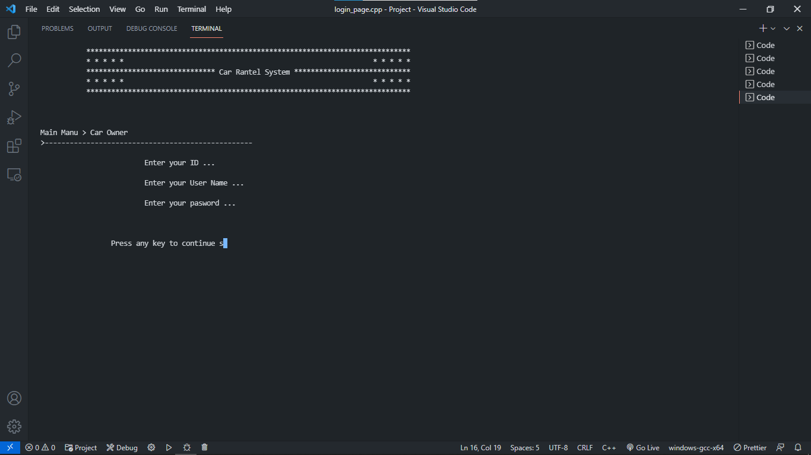

* + **This Login Page allow the Car owner to Use his user name, ID and his password to access his account on Management System.**
  + **It also gives the option to save its username and password for later use.**

Car Owner’s Module: -

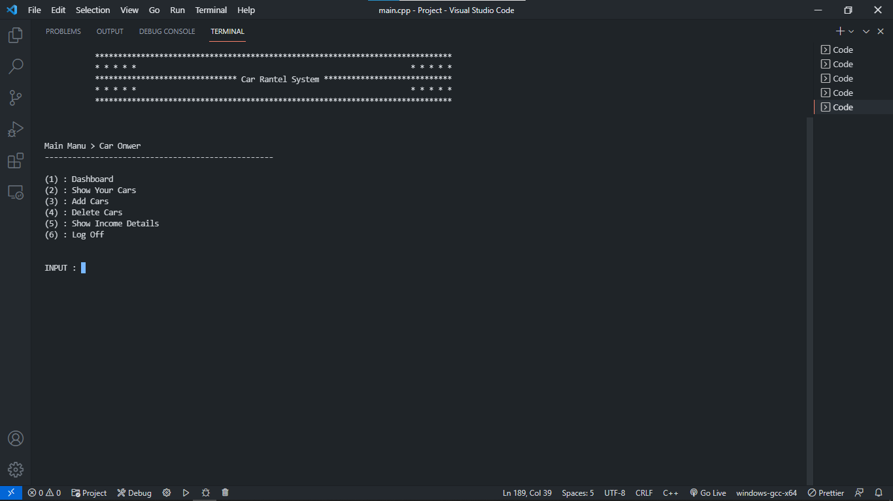

* + **In Dashboard: The owner can view his/her Own profile his/her car travelling history.**
  + **In Income detail: owner can check about income earned.**

User Login Page: -

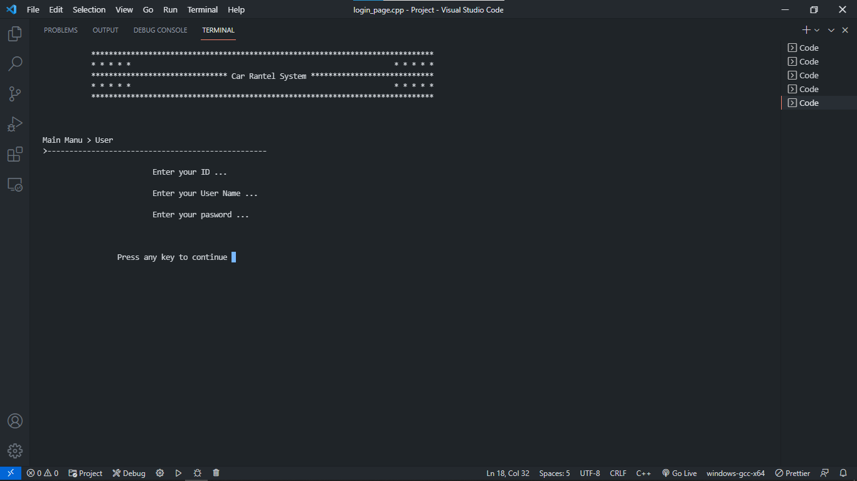

* + **This Login Page allow the user To Use his user name, ID and his password To access his account on Management System.**

User Module: -

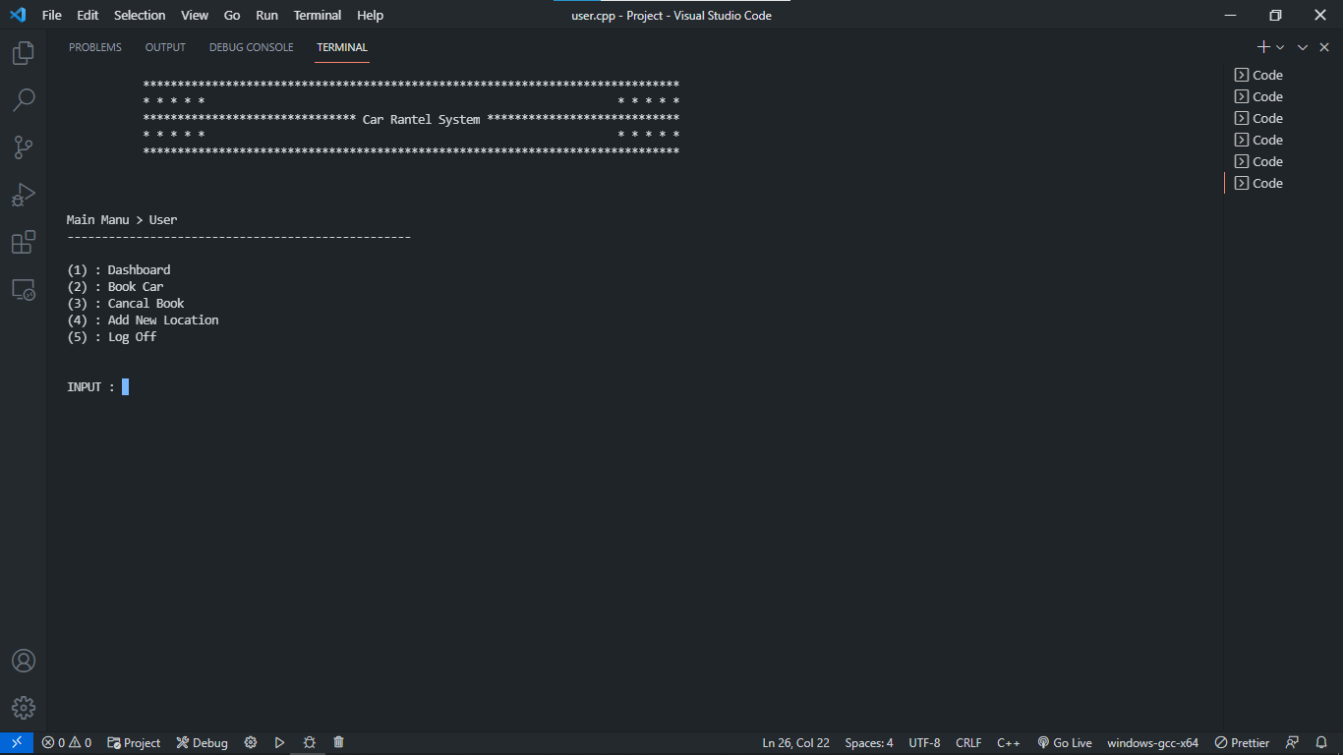

* **In Dashboard Section: User can view his/her Profile and track records.**
* **In Book Car: Customer can book a car.**
* **In Add new location: The user can see his/her new location.**